Outline of the story

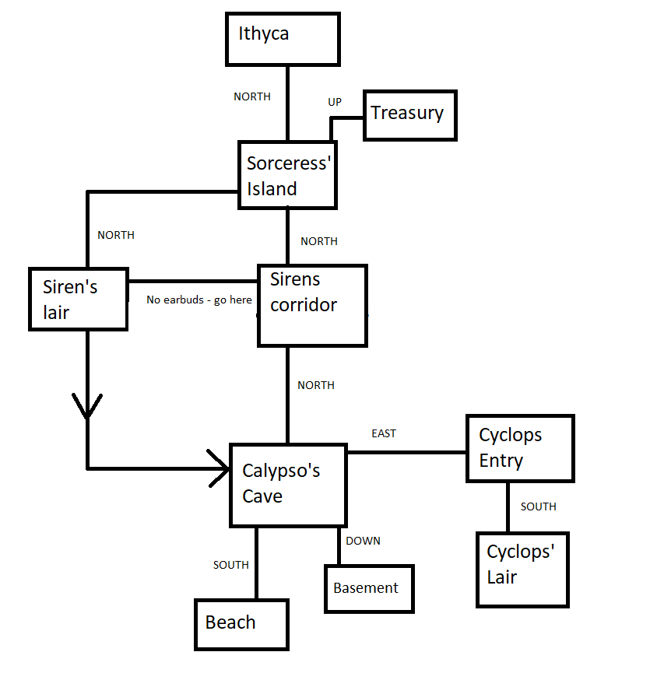

Map of the game

Calypso’s cave:

NORTH – Siren’s corridor (If raft is in inventory)

* Note displays in boat instructions “examine”

Goal – build boat and escape

EAST – Cyclops entry

DOWN – Basement

SOUTH – Beach

Basement:

UP – Calypso’s cave

Contains boxes/ chest enemy

Easy no threat battle

Drops wood item

Beach:

NORTH – Calypso’s cave

Shipwreck with rope item

“Swim” – Easter egg

Cyclops Entry:

WEST – Calypso’s cave

SOUTH – Cyclops’ lair

Stone blocks south – “Shout” to remove

Umbrella item

Cyclops Lair:

Contains cyclops enemy

NORTH – Cyclops entry

Draw examine to set items

User umbrella to blind or kill

Sturdy raft item

Earbuds item

Siren’s Corridor:

NORTH – Sorceress’s island

If no earbuds equipped – Siren’s lair

Siren’s lair:

NORTH – Sorceress’s Island

Contains Siren enemy

If lose get sent back to Calypso’s Lair

Body with booster ring item – boost stat choice

Sorceress’s island:

Examine sorceress to get “eye”

NORTH – Ithyca

SOUTH – Siren’s Corridor

UP - Treasury

If eye dropped in Cyclops’ Lair Ithyca is unlocked

Examine mentions a skeleton missing tailbone joke coccyx item can be used to summon Kryla enemy – drops “L”

Treasury:

Room has lockbox

DOWN – Sorceress’s Island

“Examine” lockbox to get new text and enter code, 4-digit number hidden in various area pictures throughout the same “0451”

Ithyca:

Given questions on examine descriptions dor certain rooms. Once correct done, fight “Suitors”, then you win.